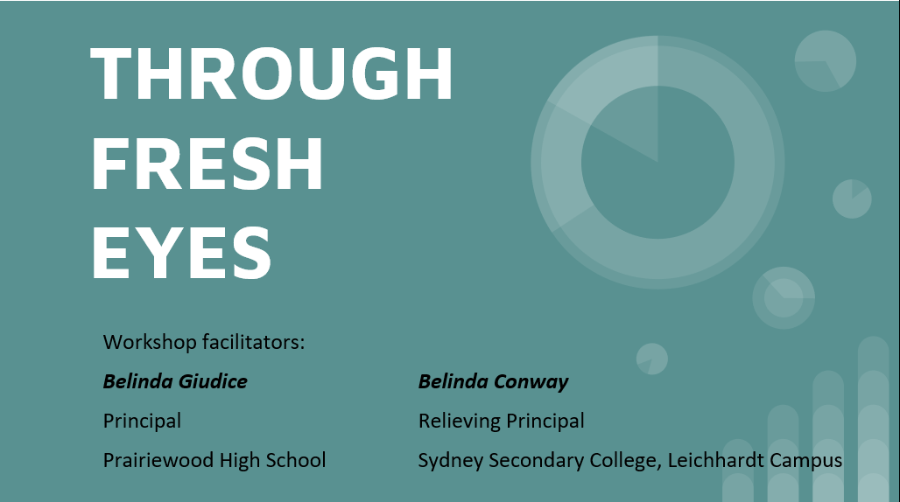

Most leaders want to get on with change- their own passion drives their agenda, timetable, sometimes with external pressure to improve. They articulate their vision and goals and build coalitions for creating the future they envisage. But change does not happen by focusing only on the future. For change to succeed, leaders need to focus as much, if not more, on understanding the practices they wish to change as on designing the alternatives they seek to introduce. (Robinson, 2018)

Robinson’s Theories of Action indicates there are intended and unintended consequences of people’s actions:
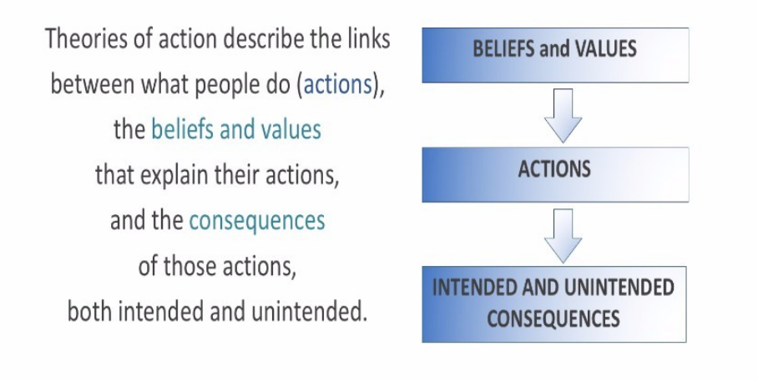

Nominate an initiative that is occurring at your school.

As a school group, complete the narrative linked to the school initiative:
- Because….
- We believe….
- So we provide….
- That leads to….
- And results in…..

Critical Question: Does the evidence match what we think?

[Good for situational analysis or reflecting:]

Three Guiding Questions for Leaders:

- What was done or not done?

- Why was that done or not done?

- What happened as a result?

Reflection Checkpoints:

- The relationships between problem and solution is elastic rather than static- design thinking
- Vision
- Relational Trust (Robinson, 2011), Generative Leadership (Ryan, 2019)

Tips and tools for evaluation:

Reflecting on the chosen school initiative, evaluate planning and progress aligned to the following tools:

- Trust and Agreement – where are staff involved at? How do we shift them to the Allies quartile?
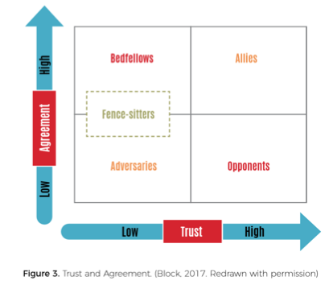
- Influencing people v’s influencing ideas? Where is the buy in?

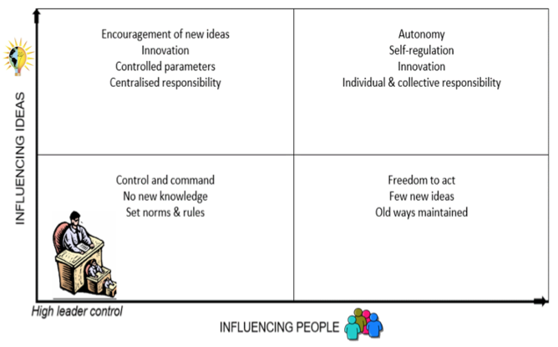

- Assessing current situation against preferred future – gives priority feedback

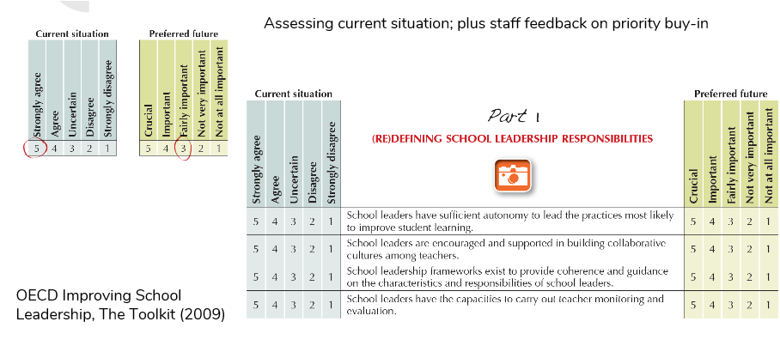
Note: These survey questions most likely do not align to your school initiative. The comparative likert scale questions would need to be determined.

- Change-management driving questions:

- Is a careful distinction made between change and improving or is it assumed that change is equivalent to improving?
- How much change is taking place in your context? What do you know about whether it is leading to improved outcomes for learners?

Further reading:

Robinson, V. (2018) Reduce Change to Increase Improvement, Thousand Oaks: Corwin

Building Relational Trust

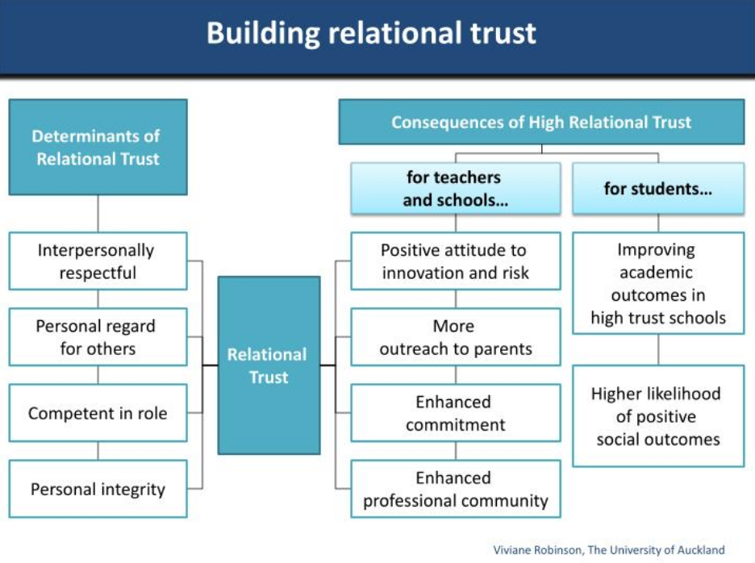

Design Theory- The Work of Bennett, Agostinho and Lockyer

Bennett, S., Agostinho, S., Lockyer, L. (2017) The process of designing for learning: understanding university teachers’ design work. Educational Technology Research and Development, 65 (1), 125-145
Findings from design studies suggest that design is an iterative endeavour, characterised by an evolving understanding of the problem and its context.

Design thinking has the potential to provide teachers with a problem-solution scaffold to reflect upon contextual and evidence-based factors

Experienced teachers consider the design problem as wide ranging and include specific opportunities for diagnostic, formative and summative assessment

Model takes into account the unique relationship in education between the problem and the ‘audience’ involved in the problem

The diagram below relates to design thinking in planning for teachers, however, could easily be broadened to any school-based initiative:

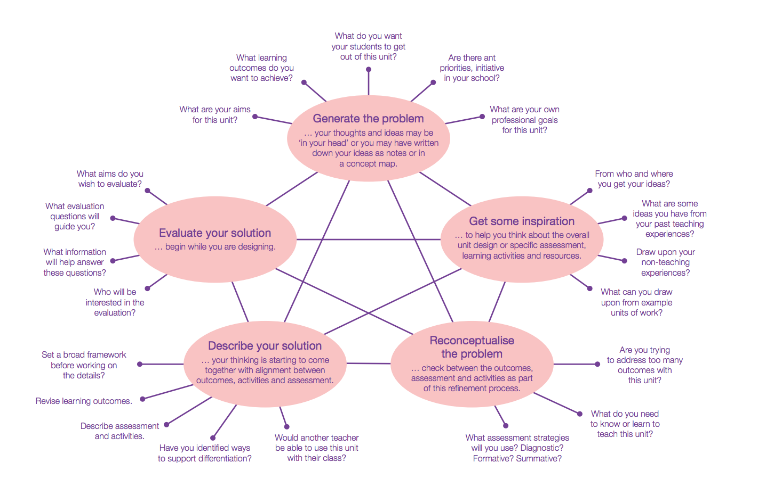
Lockyer, L. (2013) Enhancing teaching and learning through design practice

https://research.acer.edu.au/cgi/viewcontent.cgi?article=1342&context=research_conference

